Waipu Primary School
Bullying Prevention and Response Policy/Procedure
Created JULY 2020
Author T.Hayward

Rationale or Purpose
The Waipu Primary School Board of Trustees undertakes to ensure all reasonable and practicable steps are taken to develop high standards of behaviour in order to fulfil the School’s Strategic plan and the requirements of NAG 5, to include PB4L initiatives, as well as compliance required under the Health & Safety Act 2015. The Board of Trustees seeks to foster and develop a safe, positive physical and emotional school environment that creates a climate of trust. Students, staff, parents and the wider community, share the responsibility for making Waipu Primary a respectful and inclusive environment.

Policy Statement
We are committed to ensuring that our school provides an environment free from bullying behaviours. All members of our school community – Board of Trustees, school leaders, teachers, staff, students and parents and the wider community, should have an understanding of what bullying is; and know what to do when bullying does occur.
Definition
Bullying behaviour is not an individual action. Our school community agrees that:
- Bullying is deliberate
- Bullying involves a power imbalance
- Bullying has an element of repetition
- Bullying is harmful.
Bullying behaviours can be physical, verbal, or social, and can take place in the physical world or digitally.
Bullying is not an individual action. It involves up to three parties; initiators (those doing the bullying), targets (those being bullied) and often bystanders (those who witness the bullying).

Bullying Prevention
We recognise that real change happens when students, staff, parents, whānau and other members of the community share responsibility for making our school a respectful and inclusive environment. We will:
- Regularly survey our school community
- Identify areas for improvement through the survey findings and develop a bullying prevention action plan
- Regularly promote our expectations and successes in preventing bullying (eg: in assemblies, newsletters and Facebook, reports to the Board of Trustees)
- hold professional learning and development on our understanding of bullying prevention and response (staff meetings, parent meetings, student leader/Peer role modelling)
- Establish our Bullying Prevention Team to take responsibility for bullying prevention (to include staff, parents and whānau and students)
- Use a range of activities including curriculum based programmes to develop the ability for students to relate to each other (peer mediation, social problem solving solutions, role playing)
- Promote digital citizenship throughout ICT and promoting safe use of technology (through our ICT Use Agreements)
- Support the student-led peer to peer initiative.

Bullying Response, for when bullying occurs
We recognise the importance of consistently responding to all incidents of bullying that have been reported in our school and ensuring that planned interventions are used to respond to these incidents and support all involved. We will support anyone who has been affected by, engaged in or witnessed bullying behaviour.
- All reported incidents of bullying will be taken seriously and followed up as appropriate
- An appropriate adult will support the affected students by:
- reassuring that they have done the right thing in reporting the incident
- using the assessment matrix, record a description of what happened and assess the level of severity
- using the quick reference guide, responding to bullying incidents to activate the response and action needed
- We will involve parents and whānau as early as possible and as appropriate
- Major incidents will be escalated to senior management and we will seek advice and involvement from outside agencies
- We will provide appropriate support for targets, bystanders and initiators of bullying behaviour
- We will regularly monitor all incidents of bullying and identify patterns of behaviour.

Raising Awareness
We recognise the importance of good communication between home and school to promote consistent messages, and to ensure that any reported bullying can be recognised and responded to effectively. We will regularly raise the awareness of our school community’s approach to bullying and celebrate our positive school culture, for example through parent evenings, assemblies, class-based activities, and displays.
Our interaction with our wider school community will include reports to the Board of Trustees, school newsletters, and information (including the policy) on the school’s website.
We will make the policy available in multiple formats (in print, on the web and in school notices and newsletters) and ensure it is translated into other languages as necessary.

Evaluation and Review
We will review and revise this policy annually to ensure that the school's bullying prevention practices are recognised and celebrated. This will include an annual meeting to monitor, review and modify the policy and action plan (to reflect changes with the school, survey findings, incident reviews). We will track and monitor all bullying related incidents and regularly report this information to the school community. We will regularly gather data from the school community and report on the effectiveness of this policy and Waipu Primary’s community’s commitment to bullying prevention and response.

Procedures for Responding to different levels of bullying behaviour
Bullying incidents vary widely in their severity, impact on the target, and frequency.
Most bullying behaviour is hidden from adults’ view, and as such all allegations need to be taken seriously and investigated thoroughly.
This means getting an understanding of exactly what happened, considering it in relation to the definition of bullying and then implementing the school’s bullying policies and processes. The approach or disposition that a school or teacher brings to responding to bullying behaviour is critical – policies and processes alone are not enough.
Most mild incidents of bullying behaviour can be responded to effectively by students (ie, targets and bystanders) themselves, or with minimal support from teachers. However, more serious instances of bullying behaviour will require a proportionately greater response.
All instances of bullying need to be taken seriously and responded to appropriately
Some bullying may reach the level of serious assault or child abuse. Schools should not investigate such incidents themselves and must refer these to New Zealand Police and / or Child, Youth and Family (Oranga Tamariki) for follow-up (see quick reference guide).

Assessing and responding to bullying incidents
All bullying incidents should be recorded in ETAP under the Behaviour tab. The various reasons for bullying can be recoded in ETAP as
- Cyberbullying
- Harassment – Race, Gender, Faith
- Threatening Behaviour
- Verbal Bullying

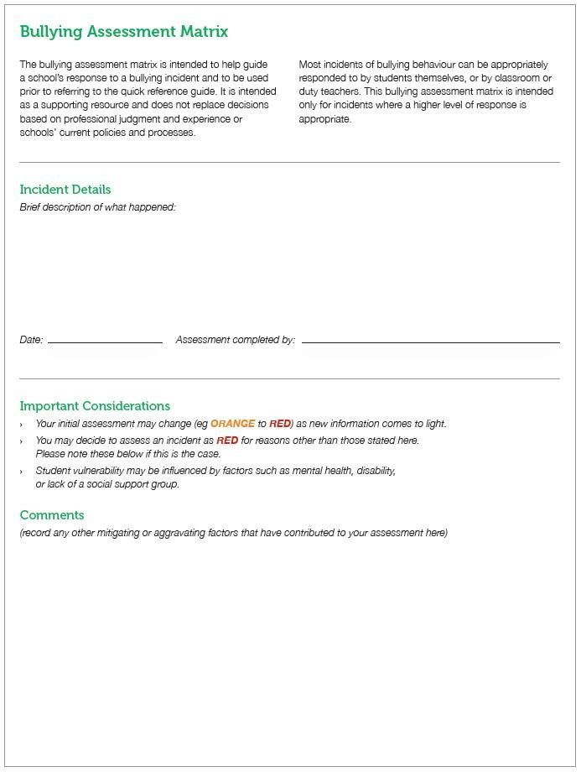

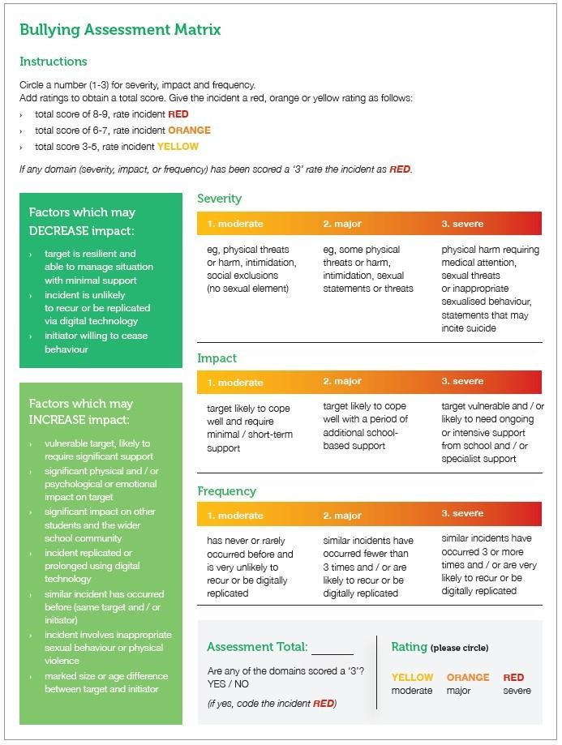

Examples
MODERATE (YELLOW):
A student (the initiator) makes inappropriate and derogatory remarks to another student (target) based on his / her ethnicity. A group of students is watching (bystanders). One or two similar incidents involving the same students have occurred over the past few weeks and the target student has received a few negative text messages. The target student is confident and assertive. He / she has told the initiator that his / her behaviour is disrespectful and inappropriate and has reported all the incidents to his / her class teacher.
Assessment rating:
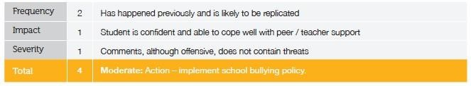
MAJOR (ORANGE):
A student (the initiator) makes inappropriate and derogatory remarks to another student (target) based on his / her ethnicity. A group of students is watching (bystanders). One or two similar incidents involving the same students have occurred over the past few weeks and the target student has received a few negative text messages. The target student is a migrant and is new to the community and to the school. He / she has not yet developed a strong peer network and is quite isolated. The remarks are particularly hurtful and intimidating and the student is feeling threatened and unsafe at school.
Assessment rating:
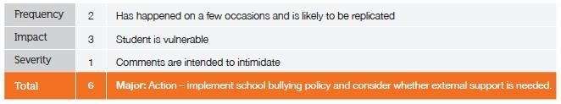

SEVERE (RED):
A student (the initiator) makes inappropriate remarks to another student (target) based on his / her ethnicity and pushes him / her to the ground while continuing to threaten and verbally abuse him / her. There is a group of students watching (bystanders). Several similar incidents involving the same students have occurred over the past few weeks and the target student has received text messages. As a result of the fear of further bullying, the student’s (target) school attendance has dropped and he / she feels very unsafe when at school.

Assessment rating: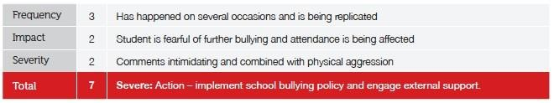
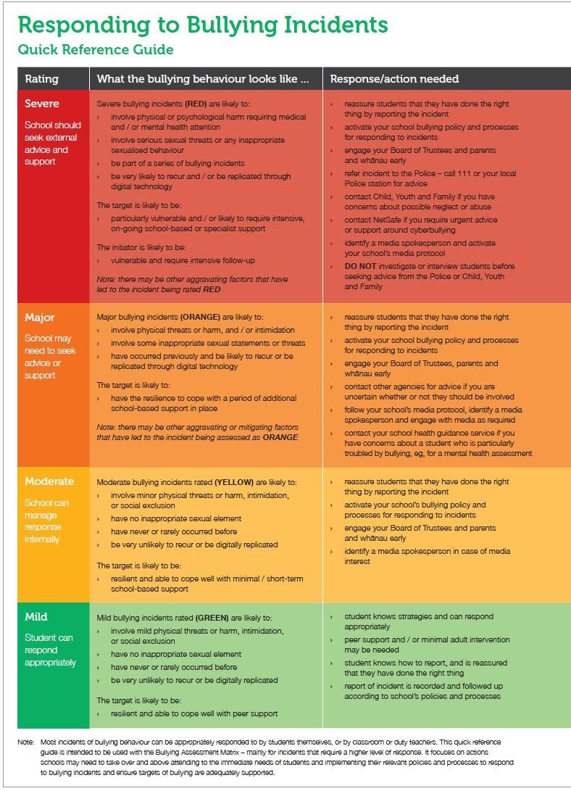

Student reports a bullying incident to a teacher
Assessing and responding to a Bullying Incident Flow Chart
Minor
Teacher determines the severity of the bullying incident using the Bullying Assessment Matrix
Moderate
Severe
Major
Incident referred to Principal and BOT
Incident referred to Principal, BOT and Police
- Principal gathers all the available facts and evidence from the Target, Bystanders and Instigator
- If facts and/or evidence is clear, contact the parents of the Target and Instigator.
- Contact between to two parties to stop.
- PB4L restorative chat to be arranged.
- Principal to arrange a meeting with parents/caregivers of Instigator.
- Peer support to be offered
- Incident recorded on ETAP
- All available facts are gathered from the Target, Bystanders and Instigator.
- Contact the parents of the Target and the Instigator
- Contact between the two parties to stop
- Contact the Police and/or outside agencies if required
- Refer Target to counsellor
- PB4L restorative chat to be arranged
- Principal to meet with parents/caregivers of all related parties
- Consideration of stand down/ suspension by BOT
- Incident recorded on ETAP
- All available facts are gathered from the Target, Bystanders and Instigator.
- If facts and/or evidence is clear, contact the parents/caregivers of the Instigator and Target
- Contact between the two parties to stop.
- Contact outside agencies if required
- Refer Target to Counsellor
- PB4L restorative chat to be arranged
- Principal to arrange a meeting with parents/caregivers of Instigator
- Consideration of Stand Down (in school or out of school)
- Incident recorded on ETAP
NB: In all cases if Bullying Behaviour continues then incident referred to next level up on the matrix

Teacher discusses strategies with the student to address the bullying
- Peer support can be offered
- Incident recorded on ETAP

Teacher refers the bullying incident to the principal

Definitions & Principles
  - Bullying is an issue that all schools will face at one time or another.
  - Bullying is a way of behaving and can be changed through effective prevention and response strategies.
  - Prevention of bullying requires schools to create safe and positive social and physical environments.
  - Schools need to set an expectation that students will report bullying and encourage students to feel comfortable doing this.
  - Effective prevention of bullying requires a whole-school approach – involving staff, students, parents and whānau (ie, the whole school community), and integrating cyberbullying and digital challenges into the overall approach.
  - Parents and whānau need to have confidence that the culture, structures and processes at their child’s school will reduce the likelihood of bullying occurring.
  - Parents and whānau need to have confidence in how their child’s school will respond when an incident of bullying does occur.
  - Student-led strategies for responding to bullying incidents should be implemented across the school. Staff who respond to an incident should work with students to create the desired outcomes (eg, using a restorative practice approach).

Definition of Bullying
- Bullying is deliberate – there is an intention to cause physical and / or psychological pain or discomfort to another person.
- Bullying involves a power imbalance – there is an actual or perceived unequal relationship between the target and the initiator that may be based on physical size, age, gender, social status or digital capability and access.
- Bullying has an element of repetition – bullying behaviour is usually not one-off. It is repeated over time, with the threat of further incidents leading to fear and anxiety. Repeated acts of bullying may involve single acts with different targets, as well as multiple acts with the same target.
- Bullying is harmful – there is short or long-term physical or psychological harm to the target (eg, as a result of coercion or intimidation).
Bullying is one particular form of aggressive behaviour and can be covert or overt in nature. Not all forms of verbal or physical aggression are bullying. For example, a student’s use of sexist or racist terms constitutes racist or sexist behaviour; if the student did not deliberately intend to cause harm by using those terms it is not bullying behaviour. Similarly, theft is theft; it is not necessarily bullying. There will always be an element of professional judgment at play in determining whether specific incidents are bullying, or not.
Bullying behaviour is not an individual action. It is influenced by the actions and values of peer groups, schools, families and whānau, communities and societies. Therefore, it is important to explore how the community around students might impact on their behaviour.
It is also important to acknowledge that bullying can have rewards for the initiators of bullying behaviour. It can increase their social status, while lowering the social status of their target. The culture of the school will strongly influence the extent to which this occurs.

Types of bullying behaviour
Bullying behaviour is complex and can take many forms, including physical, verbal, and social (or relational) bullying. All of these forms of bullying can take place in the physical environment and / or in the digital environment and all can cause damage and harm.
Verbal and social / relational bullying can be as harmful as physical bullying. As young people increasingly use a range of digital devices, the boundaries between the physical and the digital environment become increasingly blurred.
As shown in Figure 1. below, bullying behaviour can be overt (direct and easily observed) or covert (indirect and hidden or less easily observed). A great deal of bullying is covert with bullying behaviour rarely occurring in front of adults. Therefore, it is important to take all allegations of bullying seriously and to ensure they are followed up thoroughly.
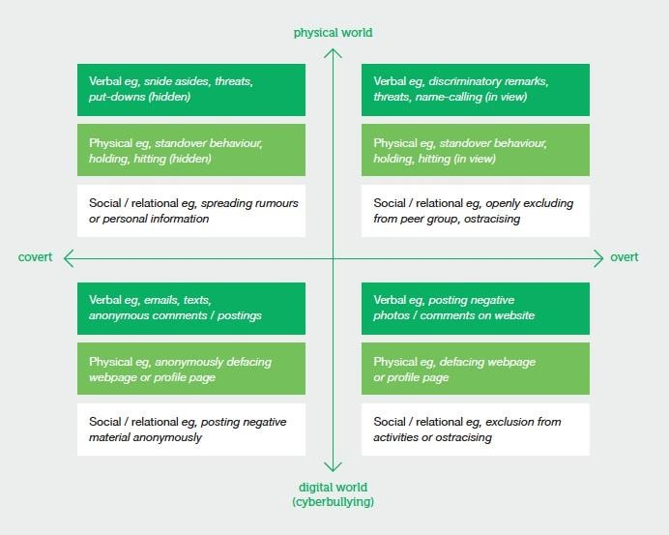

Cyber bullying
Cyberbullying is among the many digital challenges that young people encounter online. Broadly, these challenges include cyber safety, cyber security and cyber-crime. Most students are able to manage such challenges for themselves most of the time.
Digital technology brings both opportunities and challenges. It is neither inherently positive nor negative. It can be used to either deter bullying behaviour or carry out cyberbullying.
Cyberbullying is one particular form of bullying, but it doesn’t sit on its own. It is bullying that is enabled, enhanced, or in some way mediated through digital technology. Digital technology can be a medium for all kinds of bullying behaviour, including physical, verbal and social / relational bullying – and with its increasingly important role in young people’s lives, cyberbullying is becoming more prevalent. Email, cell phones, chat rooms, social networking sites and instant messaging can all be used to bully others verbally, socially or psychologically.
Young people may find themselves more easily drawn into initiating or being part of bullying behaviour in the digital environment. The ease of using technology and the influence of their peers can be a factor in this.
The characteristics of bullying behaviour described earlier may be expressed differently in the context of cyberbullying. For example:
- repetition – can be influenced by the ability of a single action to spread and be repeated rapidly to a wider audience and with a degree of permanence (eg, forwarding texts)
- power imbalance – can also be a function of the anonymity of the person initiating the cyberbullying, or of an individual’s ability to use technology (as opposed to traditional age, physical strength and social status imbalances)
- cyberbullying – can involve people who have never physically met and / or people who share no common acquaintances.
Examples of cyberbullying include:
- sending abusive texts or emails
- posting negative or inappropriate messages or images on social networking sites
- taking and sharing private images, including sexual images
- forming bullying groups on social networking sites
- assuming the identity of a target online and representing them in a way that may be harmful to them or cause them distress.
In many ways, cyberbullying is like any other form of bullying. However, bullying that takes place through digital technology has less boundaries than physical bullying. This is because digital information can be:
- rapidly duplicated, distributed, and accessed
- stored in multiple locations
- created and communicated automatically
- stored with varying levels of ‘discoverability’
- in effect at any time of the day or night
- leave a permanent record (eg, photos posted on the internet).
Cyberbullying may occur alongside bullying in a physical environment which would intensify the effect. For example, recording a bullying incident on a smartphone and then distributing the recording. One study found children who were bullied offline were 15 times more likely to be bullied online.
Covert bullying behaviour that intimidates or coerces others is powerful in both the physical and digital environments. Digital technology provides more opportunity for covert bullying because it is easy to act anonymously – and, perhaps more importantly, it offers locations that parents and teachers either do not know about or cannot access.

Effects of bullying
Bullying behaviour impacts the whole school community. Bullying has detrimental effects on students’ health, wellbeing and learning. Both the targets and initiators of bullying are at increased risk for adverse outcomes in the long-term, including early school leaving. Although most research in this area focuses on the impacts of bullying on initiators and targets, bullying may also impact negatively on bystanders, ie, those who witness bullying.
Students who are bullied are more likely to experience symptoms of depression and anxiety and to avoid going to school. Bullying that is particularly sustained, severe or intense may be linked to serious physical and mental health outcomes, including increased risk of suicide. Verbal and social / relational bullying can be just as harmful as physical bullying. Addressing bullying effectively has benefits for the future of both targets and initiators of bullying.

Initiators, targets and bystanders
Bullying behaviour involves three parties: initiators (those doing the bullying), targets (those being bullied), and bystanders (those who witness the bullying).
Initiators: Students who bully others often do so to gain status and recognition from their peers. Their bullying behaviour is reinforced when they intimidate their targets and when the peer group colludes by not challenging the initiator or reporting the bullying to staff.
Targets: Students of all ages can be at relatively greater risk of being bullied (ie, being targets) for a whole host of reasons, including: being unassertive or withdrawn (eg, isolated students with low self-esteem) differing from the majority culture of a school in terms of ethnicity, cultural or religious background, sexual orientation, gender identity, or socio-economic status having a disability, special education needs or mental health issues academic achievement (perceived as high or low achiever) having recently transitioned into a school (through natural progression through schools, changing to a new school because of behavioural issues at a previous school or moving to the area from another city or country).
Bystanders (ie, witnesses to bullying behaviour) can have a powerful effect on either encouraging or inhibiting bullying behaviour. There are three main types of bystander: followers (assistants) – do not initiate, but take an active role in the bullying behaviour supporters (reinforcers) – support the bullying behaviour (overtly or covertly, eg, by turning a blind eye) but do not take an active role in the bullying behaviour defenders – dislike the bullying and try to help the target by intervening, getting teacher support (using safe telling) or providing direct support to the target.
The diagram below is a proportional representation of the roles typically played by students involved in bullying incidents.

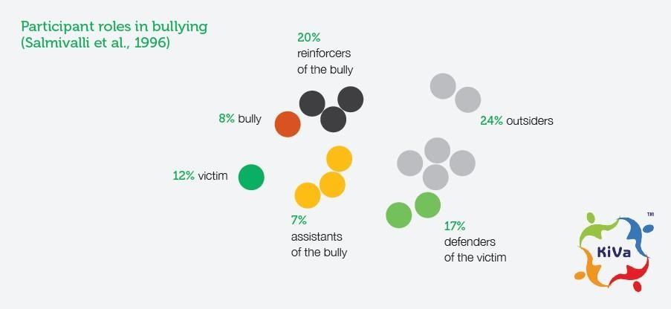

All students have the potential to occupy at least one of these roles (ie, target, initiator, or bystander) at some point in their school life. All students will transition to a new school at least once, placing them at higher risk of being bullied. It is possible that students could be in two categories at one time. For example, a student could be both a target and an initiator.
This is why it is important to involve all students in bullying prevention strategies and to ensure they are aware of their rights and responsibilities. Everyone has a role to play in preventing bullying behaviour. Bystanders need to know that responding appropriately (by discouraging, intervening in or reporting bullying) can be a very effective way to limit the impacts of, and even prevent, bullying behaviour.
Students can move in and out of the roles of initiator, target and bystander at different times. Therefore, it is important not to label particular students as ‘bullies’. Because all students may be initiators, targets or bystanders at some time, they all need to take part in strategies to learn about bullying and how to respond to it. Whole-school approaches such as PB4L, Bullying Free NZ, Kia Kaha and others take this approach and involve all staff and students.

Whole-school approaches
A safe, positive physical and emotional school environment is important for students’ achievement and wellbeing and enables all students to be included. Bullying rates vary considerably between schools with similar demographic profiles, suggesting that school culture powerfully affects the prevalence of bullying.
There is good evidence of reduced student-reported bullying when schools change their policy and culture. Evidence also suggests that effort has to be sustained or bullying recurs.
Real change happens when students, staff, parents and whānau, and other members of the community share responsibility for making their school a respectful and inclusive environment. Establishing a schoolwide expectation for mutual respect and demonstrating what that means in practice makes a difference.
Strategies to reduce bullying are most effective when they are part of a wider focus on creating a positive climate that is inclusive and supports students to learn. Whole-school interventions establish positive social values that are important to the school community. Strong leadership and staff who model these positive values and behaviours are also essential.
- Effective approaches address different aspects of school life including:
- creating a climate where diversity is respected
- developing opportunities for students to:
o build their knowledge and skills in relating to others within the curriculum and wider school activities, including the safe and responsible use of digital technology
o practice those skills through activities such as role plays
- providing high levels of social support and opportunities for social civic learning
- offering professional learning opportunities for staff.
Whole-school approaches should also extend into the local community by involving local sports groups and youth organisations, and ensuring they know about and support their school’s strategies and approach towards bullying. Parents and whānau also have an important role to play in preventing bullying.

Students with disabilities
Students with disabilities (including physical, learning, developmental, intellectual, emotional and sensory disabilities) are at greater risk of being bullied. Many factors, such as physical vulnerability, social skill challenges, and intolerant social environments and segregation can contribute to this increased risk. Positive modelling by teachers and others of respect and inclusiveness towards students who may be targets can reduce risk. Individualised approaches to preventing or responding to bullying behaviour can be included in individual education plans for students with disabilities. An emphasis on including all students and valuing diversity are powerful ways to lessen the risk that students with disabilities will experience bullying.
Schools’ bullying prevention and response strategies should apply to all students, including those with disabilities. Determining how to respond effectively to a particular instance of bullying involves taking students’ individual circumstances and support needs into account – whether they are the targets or initiators of bullying behaviour. Special Education Needs Coordinators could play a lead role in supporting other school staff to developing the strengths-based conversations around disabled students and any specific talents or needs they may have.

Students’ rights and responsibilities
Bullying behaviour compromises the ability of students to learn and achieve in school. Addressing bullying effectively is about developing school cultures that:
- are inclusive
- value diversity
- promote positive, healthy social relationships
- ensure everyone understands their rights and responsibilities (and can quickly solve problems and disputes that arise).
All students have the right to be treated with respect and dignity. In order for this to happen, it is important that students also understand they have a responsibility to treat other students with respect and dignity. Students also have rights and responsibilities relating to:
- personal security and protections from physical, emotional and sexual harassment or abuse from peers or others in the school environment
- freedom from discrimination
- participation, to express their views and have a say in matters which affect them
- an education that nurtures them to their full potential
- owning property and having it treated with respect
- being taught, and having demonstrated to them, respect for the rights of others.
Students have a right to have their family / whānau informed and involved in matters that affect them.
Bullying incidents should be dealt with in a fair manner that protects the dignity and privacy of all parties. Resolution should be aimed at achieving, where appropriate, a positive outcome for all parties with particular emphasis on ensuring that the wellbeing of the target of the bullying behaviour is restored and that any underlying issues behind the bullying behaviour are positively addressed.

This policy was developed using the following resources
- Education Act 1989
- Health & Safety Act 2015
- MoE’s “Bullying prevention and response: a guide for schools 2015
- NZPPTA “Safety in schools toolkit”
- Bully Free NZ

ANTI-BULLYING PROCEDURES
FOR
PRIMARY AND POST-PRIMARY SCHOOLS

July 2020
Author : T. Hayward

Table of Contents
- INTRODUCTION AND LEGAL FRAMEWORK ........................................................................................................... 3
  - INTRODUCTION ............................................................................................................................................................... 3
  - REQUIREMENT ON ALL SCHOOLS TO HAVE AN ANTI-BULLYING POLICY WITHIN THE FRAMEWORK OF THEIR OVERALL
CODE OF BEHAVIOUR .............................................................................................................................................................. 3 1.2 ANTI-BULLYING PROCEDURES FOR PRIMARY AND POST-PRIMARYSCHOOLS...............................................……… 4
1.3 SUMMARY OF MAIN ELEMENTS ...................................................................................................................................4
- DEFINITION AND TYPES OF BULLYING .....................................................................................................................7
  - DEFINITION OF BULLYING..................................................................................................................................................7
  - TYPES OF BULLYING ....................................................................................................................................................... ..8
- IMPACT AND INDICATORS OF BULLYING BEHAVIOUR ..................................................................................... 10
  - IMPACTS OF BULLYING BEHAVIOUR .................................................................................................................................10
  - INDICATORS OF BULLYING BEHAVIOUR ......................................................................................................................... 11
- CHARACTERISTICS ASSOCIATED WITH BULLYING .......................................................................................... 11

4.1 THE PUPIL WHO ENGAGES IN BULLYING BEHAVIOUR ................................................................................................... 11 THE PUPIL WHO IS BULLIED .......................................................................................................................................... 12 MORE VULNERABLE PUPILS .......................................................................................................................................... 12 WHERE DOES BULLYING HAPPEN? ................................................................................................................................ 13
- A SCHOOL’S ANTI-BULLYING POLICY .................................................................................................................... 15
  - REQUIREMENT TO HAVE AN ANTI-BULLYING POLICY AND TO USE THE POLICY TEMPLATE .......................................... 15
  - DEVELOPMENT OF THE POLICY .................................................................................................................................... 15
  - COMMITMENT TO KEY PRINCIPLES OF DUTY OF CARE................................................................................................... 16
5.4 COMMUNICATION OF THE POLICY ............................................................................................................................... 17
5.5 PREVENTION OF HARASSMENT...................................................................................................................................... 17
- KEY PRINCIPLES OF BEST PRACTICE .................................................................................................................... 18
  - POSITIVE SCHOOL CULTURE AND CLIMATE ................................................................................................................... 18
  - 6.2 EFFECTIVE LEADERSHIP ............................................................................................................................................ 21 6.3 A SCHOOL-WIDE APPROACH ...................................................................................................................................... 21 6.4 SHARED UNDERSTANDING OF WHAT BULLYING IS AND ITS IMPACT ........................................................................... 22
  - IMPLEMENTATION OF EDUCATION AND PREVENTION STRATEGIES INCLUDING AWARENESS RAISING ............................ 23
  - EFFECTIVE SUPERVISION AND MONITORING OF PUPILS ................................................................................................ 25
  - 6.7 SUPPORTS FOR STAFF .................................................................................................................................................... 25
6.8 CONSISTENT INVESTIGATION, FOLLOW UP AND RECORDING OF BULLYING BEHAVIOUR (INCLUDING USE OF

ESTABLISHED INTERVENTION STRATEGIES) ....................................................................................................................... 26
6.9 ONGOING EVALUATION OF THE EFFECTIVENESS OF THE ANTI- BULLYING POLICY ..................................................... 31
7. OVERSIGHT ..................................................................................................................................................................... 32

7.1 PERIODIC SUMMARY REPORTS TO THE BOARD OF TRUSTEES’ ............................................................................... 32

7.2 ANNUAL REVIEW BY THE BOARD OF TRUSTEES ................................................................................................... 32
APPENDIX 1 TEMPLATE ANTI-BULLYING POLICY ................................................................................................. 33
APPENDIX 2 PRACTICAL TIPS FOR BUILDING A POSITIVE SCHOOL CULTURE AND CLIMATE.............. 37
APPENDIX 3 TEMPLATE FOR RECORDING BULLYING BEHAVIOUR ................................................................ 39
APPENDIX 4 CHECKLIST FOR ANNUAL REVIEW OF THE ANTI-BULLYING POLICY AND ITS
IMPLEMENTATION ........................................................................................................................................................... 40
NOTIFICATION REGARDING THE BOARD OF TRUSTEES’ANNUAL REVIEW OF THE ANTI-
BULLYING POLICY............................................................................................................................................................ 41

1. INTRODUCTION AND LEGAL FRAMEWORK

1.1 Introduction
1.1.1 The role of the school is to provide an appropriate education for all its pupils. A stable, secure learning environment is an essential requirement to achieve this goal. Bullying behaviour, by its very nature, undermines and dilutes the quality of education. Research shows that bullying can have short and long-term effects on the physical and mental well-being of pupils, on engagement with school, on self-confidence and on the ability to pursue ambitions and interests.
1.1.2 School-based bullying can be positively and firmly addressed through a range of school-based measures and strategies through which all members of the school community are enabled to act effectively in dealing with this behaviour. While it is recognised that home and societal factors play a substantial role both in the cause and in the prevention of bullying, the role of the school in preventative work is also crucial and should not be underestimated. School-based initiatives can either reinforce positive efforts or help counteract unsuccessful attempts of parents to change unacceptable behaviour. Parents and pupils have a particularly important role and responsibility in helping the school to prevent and address school-based bullying behaviour and to deal with any negative impact within school of bullying behaviour that occurs elsewhere. In this document, any reference(s) to parent(s) can be taken to refer also to guardian(s) where applicable.
1.1.3 International research clearly indicates the crucial importance of the existence of and implementation of a school policy setting out the school’s approach to preventing and tackling bullying. An anti-bullying policy, when developed and implemented across the school community can be the cornerstone in countering bullying behaviour in schools.

1.2 Anti-Bullying Procedures for Primary and Post-Primary Schools
1.2.1 These Anti-Bullying Procedures for Primary and Post-Primary Schools (hereinafter referred to as “these procedures”) have been developed following consultation with the relevant education partners. These procedures have resulted from a review of the previous guidelines and the implementation of the Bullying Prevention and Response (a guide for schools)- undertaken by the Bullying Prevention Advisory Group 2015 which was published in February 2015.
1.2.2 The purpose of these procedures is to give direction and guidance to school authorities and school personnel in preventing and tackling school-based bullying behaviour amongst its pupils and in dealing with any negative impact within school of bullying behaviour that occurs elsewhere. These procedures apply to all recognised primary and post-primary schools and to centres for education (as defined in the Education Act 1989) which are attended by pupils under the age of 18 years. Where a school caters for vulnerable adults these procedures also apply to those adult learners. School authorities and school personnel are required to adhere to these procedures in dealing with allegations and incidents of bullying.
1.2.3 The Board of Trustees must formally adopt and implement an anti-bullying policy that fully complies with the requirements of these procedures. The school’s anti-bullying policy must be made available to school personnel, published on the school website (or where none exists, be otherwise readily accessible to parents and pupils on request) and provided to the Parents’ Association (where one exists). A copy of the school’s anti-bullying policy must be provided to the Ministry of Education if requested.

1.3 Summary of Main Elements
1.3.1 The following is a summary of the main elements of these procedures:
- The Board of Trustees will formally adopt and implement an anti-bullying policy that complies with the requirements of these procedures.
- The school’s anti-bullying policy will be made available to school personnel, published on the school website and be readily accessible to parents and pupils.
- Bullying is defined as unwanted negative behaviour, verbal, psychological or physical, conducted by an individual or group against another person (or persons) and which is repeated over time. These procedures make clear that this definition includes cyber-bullying and identity-based bullying (such as homophobic bullying and racist bullying).
- These procedures outline key principles of duty of care for both preventing and tackling bullying and requires the school to commit to these principles in their anti-bullying policy. The key principles are:
  - A positive school culture and climate;
  - Effective leadership;
  - A school-wide approach;
  - A shared understanding of what bullying is and its impact;
  - Implementation of education and prevention strategies (including awareness raising measures);
  - Effective supervision and monitoring of pupils;
  - Supports for staff;
  - Consistent recording, investigation and follow up of bullying behaviour (including use of established intervention strategies)
  - On-going evaluation of the effectiveness of the anti-bullying policy.
- These procedures recognise that a cornerstone in the prevention of bullying is a positive school culture and climate that is welcoming of difference and diversity and is based on inclusivity and respect. These procedures outline key elements of a positive school culture and climate and also provide schools with some practical tips for building a positive school culture and climate.
- These procedures highlight the importance of a school-wide (management, staff, pupils and parents) approach. In addition to the role of management and staff, parents and pupils have a role and responsibility in helping the school to prevent and address school-based bullying behaviour and to deal with any negative impact within school of bullying behaviour that occurs elsewhere.
- These procedures require that the prevention of bullying must be an integral part of a school’s anti-bullying policy. The education and prevention strategies that the school implements will be documented in the anti-bullying policy and will explicitly deal with the issue of cyber-bullying and identity-based bullying including in particular, homophobic and transphobic bullying.
- The school’s anti-bullying policy will also set out the school’s procedures for investigating and dealing with bullying and the school’s procedures for the formal noting and recording of bullying behaviour. The school’s procedures should be consistent with the guidance and direction set out in this document.
- These procedures emphasise that the primary aim in investigating and dealing with bullying is to resolve any issues and restore as far as is practicable the relationships of the parties involved (rather than to apportion blame).

- In any case where it has been determined by the relevant teacher that bullying behaviour has occurred-
- the parents of the parties involved should be contacted at an early stage to inform them of the matter and explain the actions being taken (by reference to the school policy); and
- the relevant teacher must keep appropriate written records which will assist his/her efforts to resolve the issues and restore, as far as is practicable, the relationships of the parties involved.
- Once bullying behaviour has been identified, the relevant staff member must refer the matter to senior management. At this time, an incident report will be completed and the flow chart, used in the case of a major incident, will be followed. All incidents of bullying will be reported to the Board of Trustees at the earliest convenience.
- As part of the oversight arrangements, the Board of Trustees must undertake an annual review of the school’s anti-bullying policy and its implementation by the school.
1.3.2 The above is a summary of the main elements of these procedures and should therefore be read within the overall context of this document.

2. DEFINITION AND TYPES OF BULLYING

2.1 Definition of bullying
2.1.1 In the context of these procedures, bullying is defined as unwanted negative behaviour, verbal, psychological or physical conducted by an individual or group against another person (or persons) and which is repeated over time.
2.1.2 The following types of bullying behaviour are included in this non-exhaustive definition:
- deliberate exclusion, malicious gossip and other forms of relational bullying;
- cyber-bullying; and
- identity-based bullying such as homophobic bullying, racist bullying, bullying based on a person’s religious or spiritual beliefs and bullying of those with disabilities or special educational needs.
2.1.3 In addition, in the context of these procedures placing a once-off offensive or hurtful public message, image or statement on a social network site or other public forum where that message, image or statement can be viewed and/or repeated by other people will be regarded as bullying behaviour.
2.1.4 Isolated or once-off incidents of intentional negative behaviour including a once-off offensive or hurtful text message or other private messaging do not fall within this definition of bullying and should be dealt with, as appropriate, in accordance with the school’s policies and procedures. A single incident can have a serious effect on a pupil and may also constitute harassment which is legally prohibited in schools under equality legislation. Harassment is any form of unwanted conduct related to any of the eight discriminatory grounds (gender including transgender, civil status, family status, sexual orientation, religion, age, disability, race).
Information on the impact, indicators and other characteristics of bullying behaviour is set out in Sections 3 and 4 of these Procedures.

2.2 Types of bullying
The following are some of the types of bullying behaviour that can occur amongst pupils:
- Physical aggression: This behaviour includes pushing, shoving, punching, kicking, poking and tripping people. It may also take the form of severe physical assault. While pupils often engage in ‘playground rough housing/fights’, they can sometimes be used as a disguise for physical harassment or inflicting pain.
- Intimidation: Some bullying behaviour takes the form of intimidation: it may be based on the use of very aggressive body language with the voice being used as a weapon. Particularly upsetting can be a facial expression which conveys aggression and/or dislike.
- Isolation/exclusion and other relational bullying: This occurs where a certain person is deliberately isolated, excluded or ignored by some or all of the class group. This practice is usually initiated by the person engaged in bullying behaviour and can be difficult to detect. It may be accompanied by writing insulting remarks about the pupil in public places, by passing around notes about or drawings of the pupil or by whispering insults about them loud enough to be heard. Relational bullying occurs when a person’s attempts to socialise and form relationships with peers are repeatedly rejected or undermined. One of the most common forms includes control: “Do this or
I won’t be your friend anymore”(implied or stated); a group ganging up against one
person (girl or boy); non-verbal gesturing; malicious gossip; spreading rumours about
person or giving them the “silent treatment”.
- Cyber-bullying: This type of bullying is increasingly common and is continuously evolving. It is bullying carried out through the use of information and communication technologies such as text, social network sites, e-mail, instant messaging (IM), apps, gaming sites, chat-rooms and other online technologies. Being the target of inappropriate or hurtful messages is the most common form of online bullying. As cyber-bullying uses technology to perpetrate bullying behaviour and does not require face to face contact, cyber-bullying can occur at any time (day or night). Many forms of bullying can be facilitated through cyber-bullying. For example, a target may be sent homophobic text messages or pictures may be posted with negative comments about a person’s sexuality, appearance etc.
- Name calling: Persistent name-calling directed at the same individual(s) which hurts, insults or humiliates should be regarded as a form of bullying behaviour. Often name calling of this type refers to physical appearance, e.g., size or clothes worn. Accent or distinctive voice characteristics may attract negative attention. Academic ability can also provoke name calling. This tends to operate at two extremes. There are those who are singled out for attention because they are perceived to be weak academically. At the other extreme there are those who, because they are perceived as high achievers, are also targeted.
- Damage to property: Personal property can be the focus of attention for bullying behaviour. This may result in damage to clothing, mobile phone or other devices, school books and other learning material or interference with a pupil’s locker or bicycle. The contents of school bags and pencil cases may be scattered on the floor. Items of personal property may be defaced, broken, stolen or hidden.
- Extortion: Demands for money may be made, often accompanied by threats (sometimes carried out in the event of the targeted pupil not delivering on the demand). A pupil may also be forced into theft of property for delivery to another who is engaged in bullying behaviour.

3. IMPACT AND INDICATORS OF BULLYING BEHAVIOUR

3.1 Impacts of bullying behaviour
3.1.1 Pupils who are being bullied may develop feelings of insecurity, humiliation and extreme anxiety and thus may become more vulnerable. Self-confidence may be damaged with a consequent lowering of self-esteem. While they may not talk about what is happening to them, their suffering is indicated through changes in mood and behaviour. Extreme cases of bullying may result in suicide. It is, therefore, essential to be alert to changes in behaviour as early intervention can be very effective.
3.1.2 Pupils who witness bullying may also be affected and may suffer in similar ways to those who are bullied. For example, pupils who witness identity-based bullying and share that identity can experience anxiety and feel under threat themselves. Pupils can also feel guilt or distress at not being able to help the person being bullied.
3.1.3 There are also consequences for individuals who engage in bullying behaviour. Pupils who become involved in such behaviour can be at higher risk of depression. Other possible long-term consequences may include an increased risk of developing an anti-social personality, anxiety disorders, a likelihood of substance abuse and law-breaking behaviour in adulthood and decreased educational and occupational attainment.

3.2 Indicators of bullying behaviour
3.2.1 The following signs and symptoms may suggest that a pupil is being bullied:
- Anxiety about travelling to and from school e.g. requesting parents to drive or collect him/her, changing travel routes, avoiding regular times for travelling to and from school;
- Unwillingness to go to school, refusal to attend, truancy;
- Deterioration in educational performance, loss of concentration and loss of
enthusiasm and interest in school;
- Pattern of physical illnesses e.g. headaches, stomach aches;
- Unexplained changes either in mood or behaviour which may be particularly
noticeable before returning to school after weekends or more especially after longer school holidays;
- Visible signs of anxiety or distress e.g. stammering, withdrawing,
nightmares, difficulty in sleeping, crying, not eating, vomiting, bedwetting;
- Spontaneous out-of-character comments about either pupils or teachers;
- Possessions missing or damaged;
- Increased requests for money or stealing money;
- Unexplained bruising or cuts or damaged clothing; and
(xi) Reluctance and/or refusal to say what is troubling him/her.
3.2.2 There may be other signs depending on the individual and his/her circumstances. The above signs do not necessarily mean that a pupil is being bullied but if repeated or occurring in combination, these signs do warrant investigation in order to establish what is affecting the pupil.

4. CHARACTERISTICS ASSOCIATED WITH BULLYING
It is important to recognise that any pupil can be bullied or can engage in bullying behaviour.

4.1 The pupil who engages in bullying behaviour
4.1.1 A significant proportion of bullying is not merely behavioural but is rooted in a lack of respect for diversity and in social inequalities. “Prejudice-based” or “identity based” bullying can be a significant factor in bullying behaviour.
4.1.2 Pupils who engage in bullying behaviour tend to display aggressive attitudes combined with a low level of self-discipline. They may lack any sense of remorse convincing themselves that the other person deserves the treatment they are receiving.
4.1.3 Pupils who engage in bullying behaviour can be attention seeking: setting out to impress bystanders and responding to the reaction their behaviour provokes. They can lack the ability to empathise. They can appear unaware or indifferent to the other person’s feelings. It is of note that pupils who exhibit bullying behaviour often suffer from a lack of confidence and have low self-esteem.
4.1.4 However, it must also be recognised that pupils who engage in bullying behaviour do not always intend to bully or may not recognise the potential negative impact of their words and actions on others.
4.1.5 It is not uncommon to find that pupils who engage in bullying behaviour may also have been bullied themselves.

4.2 The pupil who is bullied
4.2.1 Any pupil through no fault of their own may be a target of bullying. It is common in the course of normal interaction for pupils to tease or taunt each other. However, at a certain point, teasing and taunting may become forms of bullying behaviour. As pupils can be particularly quick to notice differences in others, pupils who are perceived as different in some way can be more prone to encounter such behaviour. However, the pupils who are most at risk of being bullied are those who react in a vulnerable and distressed manner. The seriousness and duration of the bullying behaviour can be related to the pupil’s continuing response to the verbal, physical or psychological aggression.
4.2.2 Pupils who are bullied often experience difficulties in speaking up about bullying. The difficulties include:
- Fear of reprisals;
- Concerns about being perceived as a “tell-tale’’ for reporting bullying;
- Concerns about “getting into trouble” with the principal or teacher for reporting bullying;
- Not having evidence to back up a bullying allegation;
- Not knowing how the matter will be dealt with by the school; and
- Not feeling fully confident of being believed.

4.3 More vulnerable pupils
4.3.1 While bullying can happen to any pupil, it is known that some may be more vulnerable to or at risk of experiencing bullying. Such vulnerable groups include pupils with disabilities or special educational needs, those from ethnic minority and migrant groups, lesbian, gay, bisexual or transgender (LGBT) pupils and those perceived to be LGBT and pupils of minority religious faiths.
4.3.2 There can be an increased vulnerability to bullying amongst pupils with special educational needs and particularly those who do not understand social cues and/or have difficulty communicating. Some pupils with complex needs may lack understanding of social situations and therefore trust everyone implicitly. Such pupils may be more vulnerable because they do not have the same social skills or capacity as others to recognise and defend themselves against bullying behaviour. Research suggests that children with disabilities and with special educational needs (SEN) are more likely to be bullied than others. Bullying can also have a more severe impact on such children. For example, some studies which compare the impact of bullying on children with and without certain disabilities, such as a speech and language difficulty, show that bullying has a greater impact on self-esteem for those with a disability.
4.3.3 Homophobic and transphobic bullying (bullying targeted at those who are or who are perceived to be LGBT) has also been found to be prevalent with evidence that such pupils have particular difficulty in speaking up or reporting the bullying behaviour.

4.4 Where does bullying happen?
Bullying can happen anywhere at any time but there are certain times and places which particularly facilitate bullying.
4.4.1 Cyber-bullying: Access to technology means that cyber-bullying can happen around the clock and the pupil’s home may not even be a safe haven from such bullying. Pupils are increasingly communicating in ways that are often unknown to adults and free from supervision. The nature of these technologies means digital content can be shared and seen by a very wide audience almost instantly and is almost impossible to delete permanently. While cyber bullying often takes place at home and at night, the impact can also be felt in school.
4.4.2 Areas of unstructured activity: Bullying in schools frequently takes place in the playground/schoolyard. School grounds with hidden or obscured parts may provide an environment conducive to bullying. Many common playground/schoolyard games present opportunities for bullying because of their physical nature. It is relatively easy to single out and bully another pupil. The noise level masks much of what is going on. The playground/schoolyard provides the opportunity for older pupils to pick on younger pupils. It can also be the setting for bullying by groups. Continuing provocation may eventually lead to a physical fight and ironically in some cases the person being bullied may appear to be the aggressor because he/she finally gives vent to his/her frustration.
Toilets, corridors, cloakrooms, locker areas, changing rooms, and assembly hall may be the scene of verbal, psychological and physical bullying. The behaviour of pupils in those areas needs careful monitoring.
4.4.3 Bullying in the classroom: Bullying may also take place in class. It may occur subtly through glances, looks and sniggers but may take the more overt form of physical intimidation. It may also be exacerbated if a classroom atmosphere prevails whereby pupils are allowed to make derogatory comments about their classmates or other teachers. However, teachers need to be alert to the underlying reasons for such comments in case pupils are trying to disclose something which is disturbing them and thus needs further investigation. Bullying may also occur between class periods irrespective of whether the class or the teacher moves.
4.4.4 Coming to and from school: The area immediately outside the school, the local shops and local neighbourhood are often the scenes of bullying. Bullying can also take place at the bus-stop or on the journey to and from school whether the individuals are walking, cycling or on school buses.

5 A SCHOOL’S ANTI-BULLYING POLICY

5.1 Requirement to have an anti-bullying policy and to use the policy template
5.1.1 As set out in Section 1.2 of these procedures, in accordance with the Education Act , 1989 , all schools are required to have an anti-bullying policy.
5.1.2 Certain elements of the policy template are standardised. Other aspects of the template provide flexibility to enable the policy to be tailored to meet our particular needs and circumstances of the pupils and our school. However, the development of the school’s policy, the policy itself, its implementation and review must be fully consistent with the guidance and directions set out in these procedures. All parts of the policy template shall be completed by the school.
5.1.3 The anti-bullying policy must be formally adopted by the Board of Trustees.

5.2 Development of the policy
5.2.1 The Board of Trustees in developing its anti-bullying policy must formulate the policy in co-operation with both teaching and non-teaching school staff under the leadership of the Principal and in consultation with parents and pupils. In this way, the development of school-wide strategies for dealing with bullying is shared by all concerned.
5.2.2 It is essential that all concerned have a clear understanding of the policy aims and content if the policy is to form the basis for developing effective strategies for dealing with the problem. The main aims of an anti-bullying policy are as follows:
- To create a safe physical and emotional environment for students and staff and to comply fully with any legislation currently in force.
- To create a school climate which is open, supportive and encourages pupils to disclose and discuss bullying behaviour;
- To raise awareness amongst the entire school community (including school management, teachers, pupils, parents, Whanau, volunteers etc.) that bullying is unacceptable behaviour;
- To ensure comprehensive supervision and monitoring through which all aspects of school activity are kept under observation;
- To provide procedures for investigating and dealing with bullying behaviour;
- To provide procedures for noting and reporting bullying behaviour;
- To develop a programme of support for those affected by bullying behaviour and for those involved in bullying behaviour;
- To work with and through the various local agencies in countering all forms of bullying and anti-social behaviour; and
- To facilitate ongoing evaluation of the effectiveness of the school’s antibullying policy.

5.3 Commitment to key principles of Duty of Care
5.3.1 Every school must explicitly state in its anti-bullying policy that the school recognises the very serious nature of bullying and the negative impact that it can have on pupils and that the school is therefore fully committed to the undertaking key principles of “Duty of care” in preventing and tackling bullying behaviour:
- A positive school culture and climate which-
  - is welcoming of difference and diversity and is based on inclusivity;
  - encourages pupils to disclose and discuss incidents of bullying behaviour in a non-threatening environment; and
  - promotes respectful relationships across the school community;
- Effective leadership;
- A school-wide approach;
- A shared understanding of what bullying is and its impact;
- Implementation of education and prevention strategies (including awareness raising measures) that-
  - build empathy, respect and resilience in pupils; and
  - explicitly address the issues of cyber-bullying and identity-based bullying including in particular, homophobic and transphobic bullying;
- Effective supervision and monitoring of pupils;
- Supports for staff;
- Consistent recording, investigation and follow up of bullying behaviour
(including use of established intervention strategies); and
- On-going evaluation of the effectiveness of the anti-bullying policy.
5.3.2 More detail in relation to each of the above principles is set out in Section 6 of these procedures.

5.4 Communication of the policy
5.4.1 As stated in Section 1.3.3, our school’s anti-bullying policy will be made available to school personnel, published on the school website. A copy of our school’s anti-bullying policy must be provided to the Ministry if requested.
5.4.2 The Board of Trustees will ensure that the policy is regularly highlighted and promoted on a school-wide basis with particular attention being given to incoming pupils and their parents. School management must ensure that pupils, parents and staff members are made aware of the relevant teachers responsible for dealing with bullying concerns. School rules and other information on bullying should be provided in pupil friendly, age appropriate formats and should be displayed around the school building.

5.5 Prevention of harassment
5.5.1 Our School has an obligation under equality legislation to take such steps as are reasonably practicable to prevent harassment and sexual harassment. Equality legislation prohibits harassment on any of the eight grounds: gender including transgender, civil status, family status, sexual orientation, religion, age, disability, race.
Under equality legislation, sexual harassment is also prohibited. These prohibitions apply to all aspects of school life, for example classrooms, sport fields or school tours.

5.5.2 The School shall not permit pupils to harass other pupils. This prohibition also applies to staff or anyone who visits the school including parents, visiting sports teams etc.

5.5.3 Our School is required to confirm in our anti-bullying policy that the school will, take all such steps that are reasonably practicable to prevent the sexual harassment of pupils or staff or the harassment of pupils or staff on any of the nine grounds i.e. gender including transgender, civil status, family status, sexual orientation, religion, age, disability, race.

6 KEY PRINCIPLES OF BEST PRACTICE

6.1 Positive school culture and climate
6.1.1 A cornerstone in the prevention of bullying is a positive school culture and climate that is welcoming of difference and diversity and is based on inclusivity and respect. We recognise that a school policy on bullying is most effective when supported by a positive school climate which encourages respect, trust, kindness, consideration and support for others.
6.1.2 Central to a positive school culture is respectful relationships across the entire school community. This encompasses relationships amongst peers (e.g. pupil to pupil, teacher to teacher) and relationships between groups (e.g. teachers and pupils, parents and teachers etc.).
6.1.3 The misconception that bullying is a normal phase of development and that it teaches pupils to toughen up needs to be challenged. Our school must endeavour to create an environment where pupils feel comfortable and free to discuss and disclose incidents of bullying. This may also require challenging prevailing attitudes so that pupils realise that they also have a responsibility for the safety and wellbeing of fellow pupils.
6.1.4 Our School should therefore encourage and strengthen open dialogue between all school staff and pupils. Our School should ensure that they provide appropriate opportunities for pupils to raise their concerns in an environment that is comfortable for the pupil. This dialogue should encompass issues that happen outside school, including cyber-bullying. In order to accomplish this, our school may also need to consider how best to address topics that are masked by prejudice and silence such as homophobic bullying.
6.1.5 Key elements of a positive school culture and climate are outlined in Table A.
Some practical tips for building a positive school culture and climate are also set out in Appendix 2. Other useful resources for schools include the Bullying Prevention and Response (a guide for schools) (published in February 2015) and the Clinical Education Psychologist Services’ (CEPS)
Education Counts.govt.nz documents for primary and post-primary schools.

Table A: Key elements of a positive school culture and climate
- Our school acknowledges the right of each member of the school community to enjoy school in a secure environment.
- Our school acknowledges the uniqueness of each individual and his/her worth as a human being.
- Our school promotes positive habits of self-respect, self-discipline and responsibility among all its members.
- Our school prohibits vulgar, offensive, sectarian or other aggressive behaviour or language by any of its members.
- Our school has a clear commitment to promoting equity in general and gender equity in particular in all aspects of its functioning.
- Our school has the capacity to change in response to pupils’ needs.
- Our school identifies aspects of curriculum through which positive and lasting influences can be exerted towards forming pupils’ attitudes and values.
- Our school takes particular care of "at risk" pupils and uses its monitoring systems to facilitate early intervention where necessary and it responds to the needs, fears or anxieties of individual members in a sensitive manner.
- Our school recognises the need to work in partnership with and keep parents informed on procedures to improve relationships on a school-wide basis.
- Our school recognises the role of parents in equipping the pupil with a range of life skills.
- Our school recognises the role of other community agencies in preventing and dealing with bullying.
- Our school promotes habits of mutual respect, courtesy and an awareness of the interdependence of people in groups and communities.
- Our school promotes qualities of social responsibility, tolerance and understanding among all its members both in school and out of school.
- Staff members share a collective responsibility, under the direction of the Principal, to act in preventing bullying/aggressive behaviour by any member of the school community.

6.2 Effective leadership
6.2.1 Effective leadership, supporting the school culture and climate that celebrates difference, is key to good practice. The role of all those in leadership roles within the school is of great importance in stimulating a school-wide approach to preventing and tackling bullying.
6.2.2 Our Principal in particular has a key role in dealing with bullying behaviour in school because he/she is in a strong position to influence attitudes and set standards in dealing with such behaviour. Our Principal and other leaders in the school, including all teachers, should strive to engender an ethos under which bullying is unacceptable. Those who are identified as leaders within the school community can ensure that practical steps are taken to challenge and respond to bullying. School leaders should also involve both staff and pupils in developing and implementing a vision of the school where diversity is accepted and celebrated.
6.2.3 As pupils model their behaviour on that of adults, Our Principal and teachers have a responsibility to act as good role-models and not misuse their authority. Moreover, they should be fair, firm, clear and consistent in their disciplinary measures.
6.2.4 The Code of Professional Conduct for Teachers published by the Teaching Council makes explicit the values and standards expected of teachers in their daily work with pupils.

6.3 A school-wide approach
6.3.1 A school-wide approach (involving school management, staff, parents and pupils) to dealing with the problem of bullying behaviour is a key element of effective practice. Bullying behaviour affects not only those immediately involved. It can affect everyone in the classroom, in the school and, ultimately, in the wider community.
6.3.2 A positive school-wide attitude and involvement can assist considerably in countering bullying behaviour in schools. In addition to the role of management and staff, parents and pupils have a role and responsibility in helping the school to prevent and address school-based bullying behaviour and to deal with any negative impact within school of bullying behaviour that occurs elsewhere. Parents should also recognise that a school that openly discusses bullying is acting positively and that they need to work with their school to ensure there is a coherent, school-wide approach to tackling the issue.
6.3.3 Bullying behaviour thrives in an atmosphere of uncertainty and secrecy in which the pupil often feels a sense of hopelessness and futility against the power being exercised by the person engaged in bullying behaviour. A high degree of school-wide vigilance and openness is important in ensuring that bullying behaviour can be adequately tackled.
6.3.4 The promotion of relevant home/school/community links is important for our school in regard to countering bullying behaviour and should be encouraged as a normal part of the school’s effective operation. For example, bullying behaviour can often occur on the journey to and/or from school. An anti-bullying school policy should embrace, as appropriate, those members of the wider community who come directly in daily contact with school pupils. School bus drivers, and local shopkeepers could be encouraged to play a positive role in assisting the school to counter bullying behaviour by reporting such behaviour to parents and/or to the school as appropriate. Through such approaches, a network is formed.
6.3.5 In certain cases, however, it may be necessary for the school to seek the assistance of other local persons and formal agencies such as Oranga Tamariki, MoE, MoH, NZSTA, Police, PPTA, Human Rights Commission, Children’s Commissioner, NZEI, Netsafe, ERO, NZCER, community workers, Netsafe etc.

6.4 Shared understanding of what bullying is and its impact

6.4.1 Our school must put in place appropriate systems to ensure that all relevant members of the school community have a shared understanding of what constitutes bullying behaviour as defined in Section 2.1 of these procedures. The manner in which our school will develop and communicate this shared understanding amongst its pupils will depend on factors such as the age and maturity of the pupils concerned.

6.4.2 The definition of bullying, the various types of bullying behaviour and the impacts of bullying as set out in Sections 2 and 3 of these procedures must be communicated and explained to the school community.

6.5 Implementation of education and prevention strategies including awareness raising
6.5.1 The prevention of bullying must be an integral part of the written anti-bullying policy of all primary and post-primary schools. Our school will document in its antibullying policy the specific education and prevention strategies that the school will implement. This may include measures being taken by the school to explicitly address the issues of cyber-bullying and identity-based bullying including in particular, homophobic and transphobic bullying.
6.5.2 Effective practice includes prevention and awareness raising measures across all aspects of bullying and involves strategies to engage pupils in addressing problems when they arise. In particular, such strategies need to build empathy, respect and resilience in pupils.
6.5.3 As self-esteem is a major factor in determining behaviour, our school should, through both our curricular and extra-curricular programmes, provide pupils with opportunities to develop a positive sense of self-worth.
6.5.4 Initiatives and programmes focused on developing pupils’ awareness and understanding of bullying, including its causes and effects, should deal explicitly with the issue of identity-based bullying and in particular homophobic and transphobic bullying. For example, the inclusion of LGBT posters on notice boards, discussions with parents about specific statements of welcome and respect for LGBT members of the school community, teaching the Social, Personal, Health Education, resource, Growing Up LGBT and participating in LGBT awareness events are just some of the ways in which our school can address homophobic and transphobic bullying.

6.5.5 Prevention and awareness raising measures must also deal explicitly with cyberbullying. The best way to address cyber-bullying is to prevent it happening in the first place. Prevention and any awareness raising measures should focus on educating pupils on appropriate online behaviour, how to stay safe while on-line and also on developing a culture of reporting any concerns about cyber-bullying. Our school-wide approach and the role of parents as outlined in Section 6.3 is of importance in this regard. The prevention and awareness raising measures should also take into account the scope for cyber-bullying to occur as a result of access to technology from within the school.
6.5.6 Our school’s approach to tackling and preventing bullying should take particular account of the needs of pupils with disabilities or with SEN, should join up with other relevant school policies and supports and should ensure that all the services that provide for such pupils work together. Approaches to decreasing the likelihood of bullying for pupils with SEN include improving inclusion, focusing on developing social skills, paying attention to key moments such as transitioning from primary to post-primary and cultivating a good school culture which has respect for all and helping one another as central.
6.5.7 Our school’s prevention and awareness raising measures need to be appropriate to the type of bullying and take into account the age and gender of the pupils involved. Our school must work to raise the awareness of bullying so that all members of the school community understand what bullying is and how the school deals with bullying behaviour.
6.5.8 The School could for example choose to have a staff day on the subject of bullying complemented by an awareness day for pupils and parents. An awareness day can help give the parents of a pupil who is being bullied the confidence to approach the school and also helps to send a clear message to the parents of a pupil who is engaged in bullying behaviour that they have a major responsibility in addressing their child’s behaviour.
6.5.9 Teachers can influence attitudes to bullying behaviour in a positive manner through a range of curricular initiatives. There are a number of curriculum components and programmes which are particularly relevant to the prevention of bullying and the promotion of respect for diversity and inclusiveness. The Bully Prevention and Response-a guide for schools document makes specific provision for exploring bullying as well as the inter-related areas of belonging and integrating, communication, conflict, friendship, personal safety and relationships. The Bully Free NZ programme at primary level, is a personal safety skills programme which seeks to enhance children’s self-protection skills including their ability to recognise and cope with bullying. Various other social, health and media education programmes can further help to address the problem of bullying behaviour.
6.5.10 There is space within the teaching (PB4L) of all subjects to foster an attitude of respect for all: to promote the value of diversity; to address prejudice and stereotyping and to highlight the unacceptability of bullying behaviour. In Reading and writing, there is a wide range of literature available which could be used to stimulate discussion. In Social Education, the interdependence of people in communities at local, national and international levels is stressed. When it comes to Wider topics references to colonisation, exploitation and dictatorships could be used to illustrate the negative aspect of power. The work could be extended into many other areas such as Art, Drama, and Physical Education. Co-operation and group enterprise can be promoted through team sports, school clubs and societies as well as through practical subjects. Sporting activities in particular can provide excellent opportunities for channelling and learning how to control aggression.

6.6 Effective supervision and monitoring of pupils
6.6.1 It is the responsibility of our schools management in conjunction with staff and pupils to develop a system under which good supervisory and monitoring measures are in place both to prevent and deal with bullying behaviour. Good supervision and monitoring systems also facilitate early intervention. Such measures might include appropriate supervision of school activities on a rota basis. The identification of “hot-spots” and “hot times” can be very beneficial in preventing and dealing with bullying in school. All pupils and in particular senior pupils (School Leaders) can be seen as a resource to assist in countering bullying.
Senior Students, where applicable, and other school clubs and societies can also be very important in this regard. Non-teaching staff should also contribute and be part of the process to counter bullying behaviour in schools. In addition, strategies and measures need to be developed to involve all parents.
6.6.2 Our school’s anti-bullying policy must confirm that appropriate supervision and monitoring policies and practices are in place to both prevent and deal with bullying behaviour.

6.7 Supports for staff
6.7.1 The Board of Trustees must ensure that members of school staff have sufficient familiarity with the school’s anti bullying policy to enable them to effectively and consistently apply the policy when required. Supports for staff should be appropriate to the individual’s role and should enable staff to recognise bullying, implement effective strategies for preventing bullying and where appropriate, intervene effectively in bullying cases.
6.7.2 The Board of Trustees must also make appropriate arrangements to ensure that temporary and substitute staff have sufficient awareness of the school’s anti-bullying policy.

6.8 Consistent investigation, follow up and recording of bullying behaviour (including use of established intervention strategies)
6.8.1 A consistent and clear approach to dealing with bullying when it occurs is essential to effective practice. This section provides guidance and direction for schools in relation to the need to use established intervention strategies and ensuring consistent recording, investigation and follow up of bullying behaviour.
6.8.2 A pupil or parent may bring a bullying concern to any teacher in the school. Individual teachers must take appropriate measures regarding reports of bullying behaviour in accordance with the school’s anti-bullying policy.
6.8.3 In these procedures, the member of teaching staff who has responsibility for investigating and dealing with bullying is referred to as the “relevant teacher”. At primary level, the relevant teacher will normally be the class teacher. At post-primary level, the school will determine, having regard to its own circumstances, which members of teaching staff have this responsibility.
6.8.4 The school’s anti-bullying policy must clearly indicate the relevant teachers in its school. It is not necessary to specify the relevant teacher(s) by name in the policy so long as it is made sufficiently clear to all which teachers in the school have this responsibility.

Established intervention strategies
6.8.5 The Action Plan on Bully Free NZ highlighted the importance of schools identifying and consistently implementing established evidence-based intervention strategies for dealing with cases of bullying behaviour and preventing its continuation.

6.8.6 There are various approaches and intervention strategies that might be used by schools. Given the complexity of bullying behaviour it is generally acknowledged that that no one intervention works in all situations. International and national research also continues to evolve in this area and the effectiveness of particular approaches continues to be reviewed.

6.8.7 Each school must therefore decide on the intervention method(s) that are best suited to its own circumstances. In identifying the most suitable intervention method(s) for a particular school, it is important to research and understand both the techniques of intervention involved and the assumptions and rationale of particular methods. One of the recommendations from Bully Free NZ is that a new national anti-bullying website will be set up and this will be a useful and ongoing resource for schools.

6.8.8 To ensure clarity among the entire school community about how bullying cases will be dealt with, the method(s) of intervention that will be used by the school must be specified in the school’s anti-bullying policy.

Procedures for investigating and dealing with bullying
6.8.9 School authorities must ensure that our school has clear procedures for investigating and dealing with bullying and that these are set out in the school’s antibullying policy. Our school’s procedures must be consistent with the following:
- The primary aim for the relevant teacher in investigating and dealing with bullying is to resolve any issues and to restore, as far as is practicable, the relationships of the parties involved (rather than to apportion blame);
- In investigating and dealing with bullying, the teacher will exercise his/her professional judgement to determine whether bullying has occurred and how best the situation might be resolved;
- All reports, including anonymous reports of bullying must be investigated and dealt with by the relevant teacher. In that way pupils will gain confidence in ‘telling’. This confidence factor is of vital importance. It should be made clear to all pupils that when they report incidents of bullying they are not considered to be “telling tales” but are behaving responsibly;
- Non-teaching staff such as office staff, special needs assistants (SENCO’s), bus drivers, caretakers, cleaners must be encouraged to report any incidents of bullying behaviour witnessed by them, or mentioned to them, to the relevant teacher;
- Parents and pupils are required to co-operate with any investigation and assist the school in resolving any issues and restoring, as far as is practicable, the relationships of the parties involved as quickly as possible;
- It is very important that all involved (including each set of pupils and parents) understand the above approach from the outset;
- Teachers should take a calm, unemotional problem-solving approach when dealing with incidents of alleged bullying behaviour reported by pupils, staff or parents;
- Incidents are generally best investigated outside the classroom situation to ensure the privacy of all involved;
- All interviews should be conducted with sensitivity and with due regard to the rights of all pupils concerned. Pupils who are not directly involved can also provide very useful information in this way;
- When analysing incidents of bullying behaviour, the relevant teacher should refer the incident to the senior management team who will then seek answers to questions of what, where, when, who and why. This should be done in a calm manner, setting an example in dealing effectively with a conflict in a non-aggressive manner;
- If a group is involved, each member should be interviewed individually at first. Thereafter, all those involved should be met as a group. At the group meeting, each member should be asked for his/her account of what happened to ensure that everyone in the group is clear about each other’s statements;
- It may also be appropriate or helpful to ask those involved to write down their account of the incident(s);
- In cases where it has been determined by the relevant teacher that bullying behaviour has occurred, the parents of the parties involved should be contacted at an early stage to inform them of the matter and explain the actions being taken (by reference to the school policy). The school should give parents an opportunity of discussing ways in which they can reinforce or support the actions being taken by the school and the supports for their pupils;
- Where the relevant teacher has determined that a pupil has been engaged in bullying behaviour, it should be made clear to him/her how he/she is in breach of the school’s anti-bullying policy and efforts should be made to try to get him/her to see the situation from the perspective of the pupil being bullied;
- It must also be made clear to all involved (each set of pupils and parents) that in any situation where disciplinary sanctions are required, this is a private matter between the pupil being disciplined, his or her parents and the school;
- Follow-up meetings with the relevant parties involved should be arranged separately with a view to possibly bringing them together at a later date if the pupil who has been bullied is ready and agreeable. This can have a therapeutic effect;
- In determining whether a bullying case has been adequately and appropriately addressed the relevant teacher must, as part of his/her professional judgement, take the following factors into account:
  - Whether the bullying behaviour has ceased;
  - Whether any issues between the parties have been resolved as far as is practicable;
  - Whether the relationships between the parties have been restored as far as is practicable; and
  - Any feedback received from the parties involved, their parents or the school Principal or Deputy Principal;
- Where a parent is not satisfied that the school has dealt with a bullying case in accordance with these procedures, the parents must be referred, as appropriate, to the school’s complaints procedures;
- In the event that a parent has exhausted the school's complaints procedures and is still not satisfied, the school must advise the parents of their right to make a complaint to the Ombudsman for Children.

Procedures for recording bullying behaviour
6.8.10 The Board of Trustees must ensure that the school has clear procedures for the formal noting and reporting of bullying behaviour and these must be documented in the school’s anti-bullying policy. All records must be maintained in accordance with relevant data protection legislation. The school’s procedures for noting and reporting bullying behaviour must adhere to the following:
- While all reports, including anonymous reports of bullying must be
investigated and dealt with by a member of the senior management team, the relevant member will use his/her professional judgement in relation to the records to be kept of these reports, the actions taken and any discussions with those involved regarding same;
- If it is established by the relevant teacher that bullying has occurred, the relevant teacher must keep appropriate written records which will assist his/her efforts to resolve the issues and restore, as far as is practicable, the relationships of the parties involved.
- The relevant senior team member must use the recording template to record the bullying behaviour.

Bullying as part of a continuum of behaviour
6.8.11 It is also important to note that bullying behaviour can be part of a continuum of behaviour rather than a stand-alone issue and in some cases behaviour may escalate beyond that which can be described as bullying to serious physical or sexual assault or harassment. To ensure that any such cases are dealt with appropriately, the school’s antibullying policy must provide for appropriate linkages to relevant external agencies and authorities where appropriate. In cases where a school has serious concerns in relation to managing the behaviour of a pupil, the advice of a Educational Psychologist should be sought.

Referral of serious cases to the HSO (Health & Safety Officer)
6.8.12 In relation to bullying in schools, The Vulnerable Children’s Act 2014 and the Child Protection Procedures for Primary and Post-Primary Schools provide that in situations where “the incident is serious and where the behaviour is regarded as potentially abusive, the school must consult the MOE and / or Child, Youth and Family (Oranga Tamariki) with a view to drawing up an appropriate response, such as a management plan”.

Supports for pupils affected by bullying
6.8.13 A programme of support for pupils who have been bullied must be in place. Such pupils may need counselling and/or opportunities to participate in activities designed to raise their self-esteem, to develop their friendship and social skills and thereby build resilience whenever this is needed.
6.8.14 A programme of support for those pupils involved in bullying behaviour must also be part of the school’s intervention process. Pupils involved in bullying behaviour need assistance on an ongoing basis. For those with low self-esteem, opportunities should be developed to increase feelings of self-worth. It is, therefore, important that the learning strategies applied within the school allow for the enhancement of the pupil’s self-worth. Pupils who engage in bullying behaviour may need counselling to help them learn other ways of meeting their needs without violating the rights of others.
6.8.15 Pupils who observe incidents of bullying behaviour should be encouraged to discuss them with teachers.
6.8.16 Details of the school’s programme for working with pupils affected by bullying must be set out in the school’s anti-bullying policy.

6.9 Ongoing evaluation of the effectiveness of the anti- bullying policy
6.9.1 The effectiveness of the school’s anti-bullying policy should be subject to continuous review in the light of incidents of bullying behaviour encountered. The school should make provision for periodic examination of the prevention and intervention strategies in place. Surveys of pupils, staff and parents can, if properly conducted, provide important information about the effectiveness of the anti-bullying measures in place and identify any significant behavioural trends that may benefit from early intervention.

6.9.2 The template in Appendix 3 for recording incidents that have been referred to the school Principal or Deputy Principal will be a valuable and readily accessible source of data in relation to bullying behaviour in the school. Data gathered from these reports must be regularly (at least once in every school year) collated and analysed with a view to monitoring levels of bullying behaviour and identifying any particular issues that require attention or any significant trends in behaviour. A record of this analysis must be retained. Appropriate responses to any issues identified should be drawn up and implemented.

6.9.3 It is recommended that the implementation and effectiveness of the antibullying policy be included as an agenda item for staff meetings so as to ensure that concerns about the policy or the welfare of individual pupils can be shared and effectively addressed.

7. OVERSIGHT

7.1 Periodic summary reports to the Board of Trustees
7.1.1When an incident of bullying has occured, the Principal must provide a report to the Board of Trustees setting out:
- the overall number of bullying cases reported (by means of the bullying recording template at Appendix 3) since the previous report to the Board and
- confirmation that all cases referred to at (i) above have been or are being, dealt with in accordance with the school’s anti-bullying policy.
7.1.2 The minutes of the Board of Trustees meeting must record the above but in doing so must not include any identifying details of the pupils involved.

7.2 Annual Review by the Board of Trustees
7.2.1 The Board of Trustees must undertake an annual review of the school’s anti- bullying policy and its implementation by the school.

7.2.2 The school must put in place an action plan to address any areas for improvement identified by the review.

Appendix 1: Template anti-bullying policy

All sections of this template must be completed
- In accordance with the requirements of the Education Act 1989, the Board of Trustees of : Waipu Primary School, has adopted the following anti-bullying policy within the framework of the school’s overall code of behaviour.

- The Board of Trustees recognises the very serious nature of bullying and the negative impact that it can have on the lives of pupils and is therefore fully committed to the following key principles of best practice in preventing and tackling bullying behaviour:
A positive school culture and climate which-
o is welcoming of difference and diversity and is based on inclusivity;
o encourages pupils to disclose and discuss incidents of bullying behaviour in a non-threatening environment; and
o promotes respectful relationships across the school community;
    - Effective leadership;
    - A school-wide approach;
    - A shared understanding of what bullying is and its impact;
    - Implementation of education and prevention strategies (including awareness raising measures) that-
    - o build empathy, respect and resilience in pupils; and
o explicitly address the issues of cyber-bullying and identity-based bullying including in particular, homophobic and transphobic bullying.
    - Effective supervision and monitoring of pupils;
    - Supports for staff;
    - Consistent recording, investigation and follow up of bullying behaviour (including use of established intervention strategies); and
    - On-going evaluation of the effectiveness of the anti-bullying policy.

- In accordance with the Bullying Prevention and Response (a guide for schools) 2015,bullying is defined as follows:
Bullying is unwanted negative behaviour, verbal, psychological or physical conducted, by an individual or group against another person (or persons) and which is repeated over time.
The following types of bullying behaviour are included in the definition of bullying:
  - Bullying is deliberate
  - Bullying involves a power imbalance
  - Bullying has an element of repetition
  - Bullying is harmful
Isolated or once-off incidents of intentional negative behaviour, including a once-off offensive or hurtful text message or other private messaging, do not fall within the definition of bullying and should be dealt with, as appropriate, in accordance with the school’s code of behaviour.
However, in the context of this policy, placing a once-off offensive or hurtful public message, image or statement on a social network site or other public forum where that message, image or statement can be viewed and/or repeated by other people will be regarded as bullying behaviour.
Negative behaviour that does not meet this definition of bullying will be dealt with in accordance with the school’s code of behaviour.
Additional information on different types of bullying is set out in Section 2 of the Bullying Prevention and Response ( a guide for schools) 2105.

4. | The relevant teacher(s) for investigating and dealing with bullying is (are) as follows:

5. | The education and prevention strategies (including strategies specifically aimed at cyber- bullying and identity-based bullying including in particular, homophobic and transphobic bullying) that will be used by the school are as follows (see Section 24 & 28 of the Bullying Prevention and Response (a guide for schools) 2015.

6. | The school’s procedures for investigation, follow-up and recording of bullying behaviour and the established intervention strategies used by the school for dealing with cases of bullying behaviour are as follows (see Section 3 & 4 of the Bullying Prevention and Response (a guide for schools) 2015.
7. | The school’s programme of support for working with pupils affected by bullying is as follows (see Section 2.9 and 2.11 of the Bullying Prevention and Response (a guide for schools) 2015.

- Supervision and Monitoring of Pupils

The Board of Trustees confirms that appropriate supervision and monitoring policies and practices are in place to both prevent and deal with bullying behaviour and to facilitate early intervention where possible.

- Prevention of Harassment

The Board of Trustees confirms that the school will, in accordance with its obligations under equality legislation, take all such steps that are reasonably practicable to prevent the sexual harassment of pupils or staff or the harassment of pupils or staff on any of the eight grounds specified i.e. gender including transgender, civil status, family status, sexual orientation, religion, age, disability, race.

- This policy was adopted by the Board of Trustees on ________________ [date].

- This policy has been made available to school personnel, published on the school website (or where none exists, is otherwise readily accessible to parents and pupils on request) and provided to the Parents’ Association (where one exists). A copy of this policy will be made available to the MoE if requested.

- This policy and its implementation will be reviewed by the Board of Trustees, once in every school year. Written notification that the review has been completed will be made available to school personnel, published on the school website (or where none exists, be otherwise readily accessible to parents and pupils on request) and provided to the Parents’ Association (where one exists). A record of the review and its outcome will be made available, if requested, to the MoE.

Signed: ____________________________________ Signed: ___________________________
(Chairperson of Board of Management) (Principal)

Date: ______________ Date: __________________

Date of next review: _______________

Appendix 2 Practical tips for building a positive school culture and climate
The following are some practical tips for immediate actions that can be taken to help build a positive school culture and climate and to help prevent and tackle bullying behaviour.

- Model respectful behaviour to all members of the school community at all times.
- Explicitly teach pupils what respectful language and respectful behaviour looks like, acts like, sounds like and feels like in class and around the school.
- Display key respect messages in classrooms, in assembly areas and around the school. Involve pupils in the development of these messages.
- Catch them being good - notice and acknowledge desired respectful behaviour by providing positive attention.
- Consistently tackle the use of discriminatory and derogatory language in the school – this includes homophobic and racist language and language that is belittling of pupils with a disability or SEN.
- Give constructive feedback to pupils when respectful behaviour and respectful language are absent.
- Have a system of encouragement and rewards to promote desired behaviour and compliance with
the school rules and routines.
- Explicitly teach pupils about the appropriate use of social media.
- Positively encourage pupils to comply with the school rules on mobile phone and internet use. Follow up and follow through with pupils who ignore the rules.
- Actively involve parents and/or the Parents’ Association in awareness raising campaigns around social media.
- Actively promote the right of every member of the school community to be safe and secure in school.
- Highlight and explicitly teach school rules in pupil friendly language in the classroom and in common areas.
- All staff can actively watch out for signs of bullying behaviour.
- Ensure there is adequate playground/school yard/outdoor supervision.
- School staff can get pupils to help them to identify bullying “hot spots” and “hot times” for
bullying in the school.
  - Hot spots tend to be in the playground/school yard/outdoor areas, changing
rooms, corridors and other areas of unstructured supervision.
  - Hot times again tend to be times where there is less structured supervision such as
when pupils are in the playground/school yard or moving classrooms.
- Support the establishment and work of student leaders.

Appendix 3 Template for recording bullying behaviour

- Name of pupil being bullied and class group

Name _________________________________________Class__________________

- Name(s) and class(es) of pupil(s) engaged in bullying behaviour
_________________________________________________________________________________
_________________________________________________________________________________ _________________________________________________________________________________

- Source of bullying concern/report 4. Location of incidents (tick
(tick relevant box(es))* relevant box(es))*
Pupil concerned  Other Pupil  Parent  Teacher  Other | Playground  Classroom  Corridor  Toilets  School Bus  Other
- Name of person(s) who reported the bullying concern

- Type of Bullying Behaviour (tick relevant box(es)) *
Physical Aggression |  | Cyber-bullying
Damage to Property |  | Intimidation
Isolation/Exclusion |  | Malicious Gossip
Name Calling |  | Other (specify)

- Where behaviour is regarded as identity-based bullying, indicate the relevant category:

Gender discrimination | Disability/SEN related | Racist | Religious/Faith based | Other (specify)

- Brief Description of bullying behaviour and its impact

- Details of actions taken

Signed ______________________________ (Relevant Teacher) Date ___________________________

Date submitted to Principal/Deputy Principal ___________________

Appendix 4 Checklist for annual review of the anti-bullying policy and its

implementation
The Board of Trustees (the Board) must undertake an annual review of the school’s anti-bullying policy and its implementation. The following checklist must be used for this purpose. The checklist is an aid to conducting this review and is not intended as an exhaustive list. In order to complete the checklist, an examination and review involving both quantitative and qualitative analysis, as appropriate across the various elements of the implementation of the school’s anti-bullying policy will be required.
Yes /No
Has the Board formally adopted an anti-bullying policy that fully complies with the requirements of the Bullying Prevention and Response (a guide for schools) 2015?

Has the Board published the policy on the school website and provided a copy to the parents’ association?
Has the Board ensured that the policy has been made available to school staff (including new staff)?
Is the Board satisfied that school staff are sufficiently familiar with the policy and procedures to enable them to effectively and consistently apply the policy and procedures in their day to day work?
Has the Board ensured that the policy has been adequately communicated to all pupils?

Has the policy documented the prevention and education strategies that the school applies?

Have all of the prevention and education strategies been implemented?

Has the effectiveness of the prevention and education strategies that have been implemented been examined?
Is the Board satisfied that all teachers are recording and dealing with incidents in accordance with the policy?
Has the Board received and minuted the periodic summary reports of the Principal?

Has the Board discussed how well the school is handling all reports of bullying including those addressed at an early stage and not therefore included in the Principal’s periodic report to the Board?
Has the Board received any complaints from parents regarding the school’s handling of bullying incidents?
Have any parents withdrawn their child from the school citing dissatisfaction with the school’s handling of a bullying situation?
Have any Ombudsman for Children investigations into the school’s handling of a bullying case been initiated or completed?
Has the data available from cases reported to the Principal (by the bullying recording template) been analysed to identify any issues, trends or patterns in bullying behaviour?
Has the Board identified any aspects of the school’s policy and/or its implementation that require further improvement?
Has the Board put in place an action plan to address any areas for improvement?

Signed _____________________________________ Date ________________ Chairperson, Board of Management

Signed _____________________________________ Date ________________ Principal

Notification regarding the Board of Trustees’ annual review of the

anti-bullying policy

To: _____________________________________

The Board of Trustees; of Waipu Primary School wishes to inform you that:

- The Board of Trustees annual review of the school’s anti-bullying policy and its implementation was completed at the Board meeting of _______________ [date].

- This review was conducted in accordance with the checklist set out in Appendix 4 of the MoE’s -Bullying Prevention and Response (a guide for schools) 2015.

Signed _____________________________________ Date ________________ Chairperson, Board of Trustees’

Signed _____________________________________ Date ________________ Principal

