

Application: Scale A Teacher Position - 2027
Kia ora applicant,
Thank you for expressing an interest in the permanent scale A teacher position available at Waipu Primary School. We are looking for a kaiako/teacher who is a team player, has excellent behaviour management skills, is willing to work hard, share and learn from others and enjoy their job.

We have a collaborative, supportive, reflective team who develop programmes that deliver an outstanding education, focused on helping students to be the best they can be.
Waipu Primary School truly is a remarkable and rewarding place to teach and we look forward to your application.

The following is included in this document:

- Information about our school
- Criteria for appointment
- Teacher role description
- Application for appointment

Additional information about our school can be obtained from the school website www.wps.school.nz

Our current Annual and Strategic Plan is available on the school’s website.

Please ensure that your cover letter clearly addresses:
- How you would meet the requirements of the position as outlined in the advertisement
- Your experiences relating to the Person Characteristics

The completed application for appointment is to be emailed to: principal@wps.school.nz
Timeline for Scale A Appointment - 2027

- 1st November 26: Advertisement submitted to the Education Gazette
- 4th November 26: Appointments committee established at the BoT meeting.
- 13th November 26: Applications close, 5pm.
- 14th - 15th November 26: Shortlisting
- 16th November 26: Shortlisted candidates invited for an interview.
- 18th November 26: Interviews
- 19th - 20th November: Successful candidate notified; unsuccessful candidates notified.
- 28th January 2027: Successful candidate takes up position.
Ngā mihi nui,

Belinda Bunny
Tumuaki/Principal

School Description

Waipu Primary School Pepeha

Ko Manaia te maunga
Ko Waihoihoi te awa
Ko Takahiwai te marae
Ko Waipu te whenua
Ko Waipu te kura
Waipu Primary School is a semi-rural Year 0-6 primary school situated in Waipu which is part of the beautiful Bream Bay community. The present school roll is 261 with 11 classrooms. We believe strongly in our school values, atawhai/kindness, whakaute/respect and manawaroa/resilience which are displayed throughout the school by the work and behavioural standards of our students.
We base our teaching and learning programmes on developing personal excellence through our ‘SOAR Capabilities’.
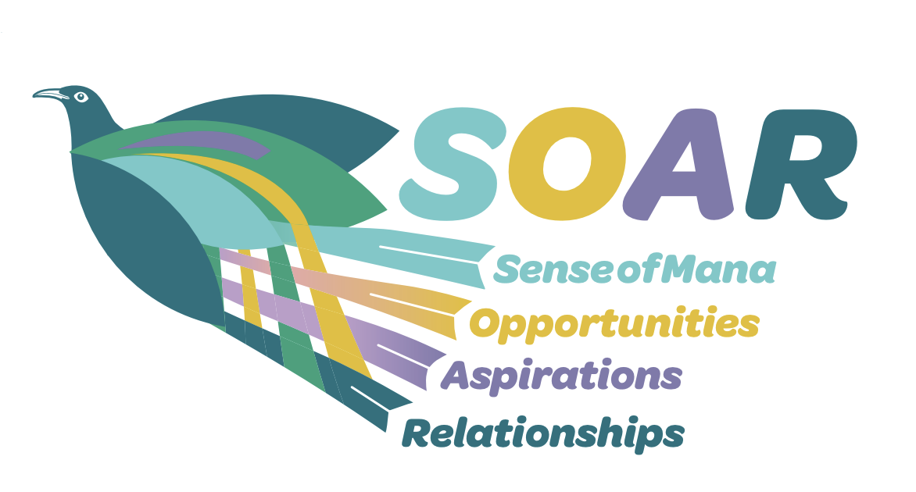
Mā te huruhuru ka rere te manu
Adorn the bird with feathers so it may soar

We want our people to develop the following capabilities.
We want them to SOAR towards excellence.

Sense of Mana | Opportunities | Aspirations | Relationships
Self Belief | Innovative | Academic progress | Kaitiaki/Leadership
Responsible | Curious | Ownership | Accept diversity
Confident | Contributing | Determined | Culturally Responsive
Connected | Courageous | Pride | Collaborative

 |  | 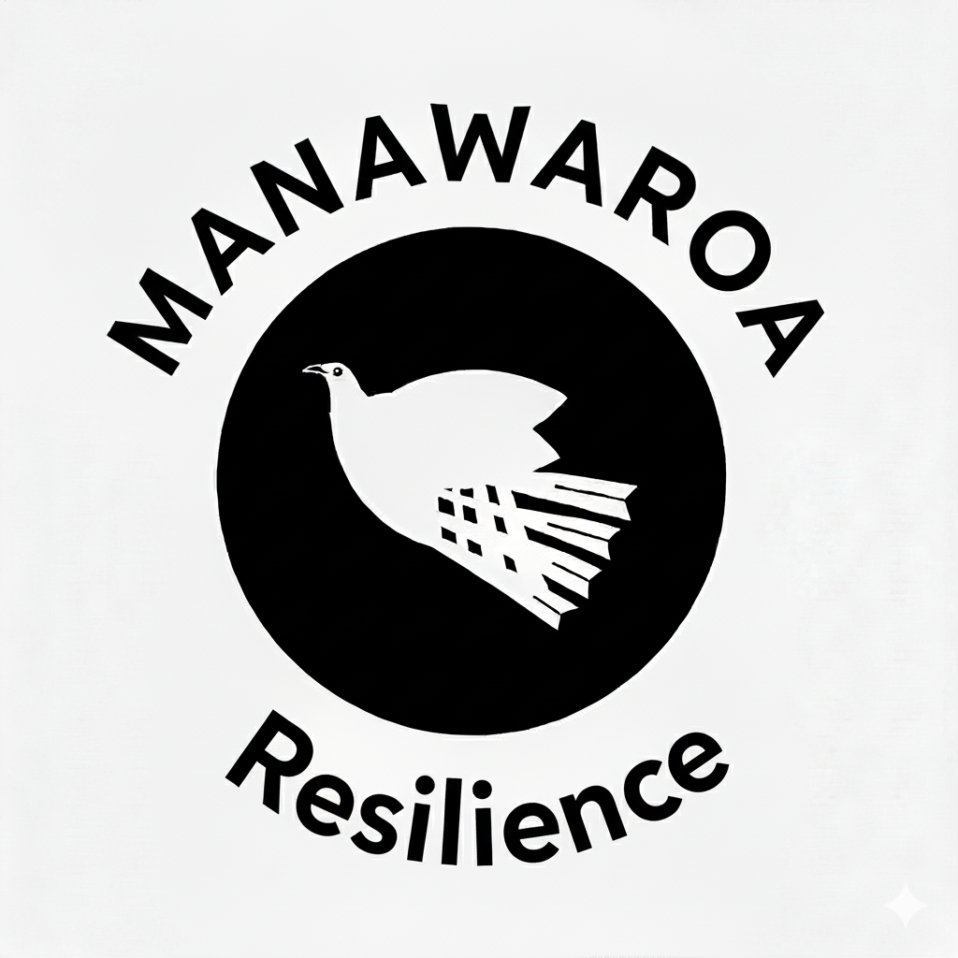

Each of these capabilities can be broken down further….
Sense of Mana
Self Belief | Believe you can do it and know that we all have a valued position in our school/community - we are all part of the Waipu team.
Responsible | Make good choices & be responsible for our actions - make decisions with moral courage and integrity. Understand how our actions affect others - be reflective of our actions and behaviours.
Confident | Be able to talk about our whakapapa, history, culture and language and be proud of who we are so we can confidently carry who we are, wherever we go. Confidently know what our strengths are and that everyone has positive attributes to contribute.
Connected | See our cultures reflected in our environment - knowing that we belong and can contribute meaningfully to our kura and the world around us.

Opportunities
Innovative | Be creative, seeing the possibilities for improvement and enhancement, putting ideas together in new ways, being open to new ideas and to doing things differently. Use creativity and imagination to problem-solve and innovate.
Curious | To ask - what else is there? Not being content with what you know, engage in what others have to offer. Be inquisitive, open to new ideas and to doing things differently. Desire to seek and acquire new skills and knowledge and be open-minded.
Contributing | Contribute meaningfully to our local communities, Aotearoa and the world around us both environmentally and as a good citizen. Work collectively as part of a team, playing an equal part in creating success. Actively participate in school activities and take the initiative.
Courageous | Feel empowered to ask for help, to gain a deeper and richer understanding of what to do, going outside of our comfort zone and be prepared to give things a go. Make the decision to do the right thing when those around you might not – have integrity.

Aspiration
Academic Progress | Be self-disciplined, ask for and act on constructive feedback and hold high expectations for ourselves and each other.
Ownership | Set goals that are learning orientated and complete tasks to the best of our ability. Manage our belongings, ourselves, our learning, our responsibilites. Take ownership of our decisions, actions and mistakes - own it, fix it, learn from it. Aim to be the best that we can be and understand that we are responsible for ourselves.
Determined | Self-assess and make improvements. Set and work hard to achieve goals with determination, and a ‘never give up’ attitude. Use creativity and imagination to problem solve and innovate.
Pride | Aspire to feel proud of ourselves, our achievements, whānau, kura and others.

Relationships
Kaitiaki/Leadership | Take care of ourselves, each other and the environment. Lead with pride and purpose by setting a positive example to others.
Accepting of Diversity | Understand and be accepting of differences in other people's abilities, outlooks, and thinking. Be open to new ideas and ways of doing things differently.
Culturally responsive | Be able to compare and contrast different points of views respectively by acting mindfully about the values, perspectives and needs of others.
Collaborative | Show gratitude when learning from and working with others who think about the world differently from ourselves. Work effectively and openly with others to complete a task or activity. Be willing to consider others points of view and perspectives. Develop a ‘We do’ attitude - there is no I in ‘team’. Know that our strength is in our unity.

Person Characteristics

The Scale A teacher we appoint will:

- be culturally responsive
- be an effective facilitator of learning with a clear understanding of ‘High Leverage Teaching Practices’; our ‘SOAR Capabilities’ and the ‘Relationships First - Teaching to the North East’ pedagogy.
- follow an ‘assessment for learning’ pedagogy
- have excellent behaviour management strategies
- be someone who is a team player
- positively engage with students, staff and the school community
The Scale A Teacher Job Description is attached.
Application for Appointment

Thank you for applying for a position within our school. Please ensure you refer to and reflect on the person characteristics, syndicate level and attached job description before completing this application.

- Please fully complete this form personally. Read it through first then answer all questions and make sure you sign and date where indicated on the last page.
- Attach a curriculum vitae (CV) containing any additional information. If you include written references, please note that we may contact the writers of the references.
- If successful in your application, you will be required to provide originals as proof of qualifications.
- If you are selected for an interview, you may bring whānau/support people at your own expense. Please advise if this is your intention.
- Failure to complete this application and answer all questions truthfully may result in any offer of employment being withdrawn or appointment being terminated, if any information is later found to be false.
In terms of a criminal conviction, the criminal records (Clean Slate) Act 2004 provides certain convictions do not have to be disclosed providing:
- you have not committed any offences within 7 (consecutive) years of being sentenced for the offence and,
- you did not serve a custodial sentence at any time (this would exclude serious offences such as murder, manslaughter, rape and causing serious bodily harm) and
- the offence was not a specified offence (specified defences are in the main sexual in nature) and,
- you have paid any fines or costs.

Custodial sentences include ascendance of preventative detention and corrective training. Non-custodial sentences include fines, reparation orders, community-based sentences and suspended sentences. Please note that you are not obliged to disclose convictions if you are an eligible individual but can do so if you wish. If you are uncertain as to whether you are eligible, contact the Ministry of Justice.

Under the Vulnerable Children Act 2014, core workers in schools will not be covered by the Clean Slate.

All serious sexual violent offences against children will be included in the police vetting results. The Act makes it unlawful to employ people with convictions for these offences, unless they have an exemption.

This application form and supporting documents will be held by the school. You may access it in accordance with the provisions of the Privacy Act 1993. If you have any queries please contact the Principal, Belinda Bunny - principal@wps.school.nz

Proof of Identity
Your appointment will be conditional on you providing proof of identity. You will need to provide two types of identification (one photo ID e.g. passport, New Zealand drivers licence and the other a record ID e.g. birth certificate, bank statement, utility account).


Application Form

To be completed in full and returned & received either by email or post before 5pm, Friday 13th November 2027.

Postal Details To: Appointments Committee (Envelopes should be endorsed ‘Confidential Application’).

Position Applied For: Scale A, permanent position.
Personal Details
Full name:
If you are known by another name please state
Address

Contact Telephone Number/s
Personal Email
NZ Teacher Registration Status
NZ Teacher Reg Number & Expiry Date
MoE Number
NZ Drivers Licence Number & Version

Qualifications
Qualification Attained | Name of Institution | Date Awarded

Please tick the appropriate boxes: ✓ | Y | N
Are you a New Zealand citizen?
If not, do you have resident status, or
A current work permit?
Have you ever had a criminal conviction (convictions under the clean slate scheme excluded)?
If “Yes” please detail:
Please tick the appropriate boxes: ✓ | Y | N
Have you ever been convicted of a driving offence which resulted in temporary or permanent loss of license, or imprisonment? If “Yes” please detail below.

Are you awaiting sentencing or have charges pending? If yes, please state the nature of the conviction/cases pending below.

In addition to other information provided, are there any other factors that we should know to assess your suitability for appointment and your ability to do the job?

If “Yes’, please elaborate below.
please see CV and cover letter

Have you ever been subject to any concerns involving student safety?

If “Yes” please detail below.

Please tick the appropriate boxes: ✓ | Y | N
Have you had any injury or medical condition caused by a gradual process, disease or infection, such as occupational overuse syndrome, stress or repetitive strain injuries, which the task of this position may aggravate or contribute to?

If “Yes” please detail below.

Employment History
Please list your work experience in your last five positions beginning with your most recent position held. If you were self-employed, give details. If you have had more than five positions in the last five years, please list them all. Attach additional sheets if necessary.

School | Position held | Reason for leaving | Period employed

Referees
Please provide the names of three people who could act as referees for you. At least one of these referees should be someone who has been team leader or Deputy Principal and you have reported to. If you have included written references from people other than those recorded below, please note that we may contact the writers of these references.
Name | Contact Details  (Organisation & Address) | Phone  (Mobile, work, home) | Relationship  (e.g. BoT Presiding Member, Principal), including how long you have known the person

Authority to approach other referees | Y | N
I authorise the Board, or nominated representative, to approach persons other than the referees whose names I have supplied, to gather information related to my suitability for appointment to the position.
I authorise the Board, or nominated representative, permission to access any information held by the Teaching Council -Matatū Aotearoa or any other educational organisation, including information regarding matters under investigation, to gather information related to my suitability for the appointment to the position.

Any other information
Please use the following space to provide any additional information that you wish the Board to consider when reflecting on your application.

Signature and Date
I certify that:
- The information I have supplied in this application is true and correct.
- I confirm in terms of the Privacy Act 2020 that I have authorised access to referees.
- I understand that if I have supplied incorrect or misleading information, or have omitted any important information, I may be disqualified from appointment, or if appointed, may be liable to be dismissed.
Signature: |  | Date:

Please ensure this form is completed fully and included along with your personal curriculum vitae and covering letter in your application.
Applications close at 5pm on Friday the 4th of July 2025.. For further information please contact Belinda Bunny, Principal - principal@wps.school.nz
Email application to:
principal@wps.school.nz
Post or courier application to:
Confidential - Appointments Committee
Waipu Primary School
6 Argyle Street
Waipu 0510

